Java Layouts

Java programs are designed to run on a wide variety of platforms (including inside web pages). Java doesn’t know how big the visual elements (or components) are going to be nor does it know how big its window is going to be. In addition, the window could be resized at any time. Java, therefore, does not place the elements at specific positions. It uses a very flexible method of placing components called Layouts. Whenever you create a Frame or window (referred to as “containers”), a Layout Manager is created, which is responsible for the placement of the components. It does this based on the layout that the programmer has assigned to the container.

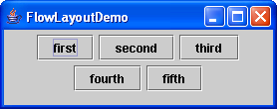
FlowLayout

The default layout is called the “Flow Layout”. Flow layout places components from left to right in the container until it is out of room, then starts at the left again below the largest component above. If the container is resized, the components will be laid out again to fit the new size. Rows of components are centered, components keep their natural size and you can add as many components as you want to a FlowLayout.

Copy the “FlowLayoutDemo” from the shared folder to your M: drive and run it. Resize the window to see how the layout of the buttons changes.

Because the flow layout is not always what you want, Java provides several other layouts as well. The most common are described below. Run each demo and resize the window.

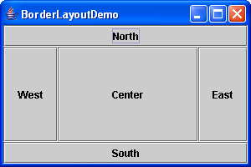
BorderLayout

The container is divided into 5 regions called north, south, east, west and center as shown by BorderLayoutDemo. When you add a component to the layout, you specify which region to place it in. You can only put one component in each region, and the component is resized to fill the entire region.
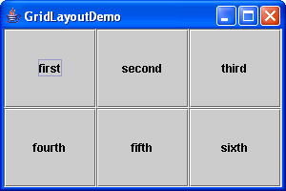
GridLayout

GridLayout divides the container into a grid with the number of rows and columns specified when the layout is created. Components are added to the grid from left to right, top to bottom. You can only put one component in each region, and the component is resized to fill the entire region.
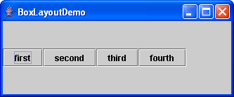
BoxLayout

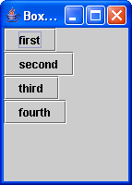
BoxLayout creates a single row or column of components depending on the alignment that you specify (Y_AXIS for a column or X_AXIS for a row). Components are added to the grid from left to right or from top to bottom. Components keep their natural size and you can add as many components as you want to a BoxLayout. BoxLayout will not wrap lines, so if the container is not wide enough or tall enough, some components will be cut off or not visible at all.

Nested Layouts

Obviously these layouts are not enough for all the programs that people might want to write. BorderLayout and GridLayout seem very limited because you can only add one component to each region. However, the component that you add could be another container, with its own layout. By doing this you can put one layout inside another – called “nesting” layouts. Several simple examples are shown below. For your programs, you will have to decide what combination of layouts to use.

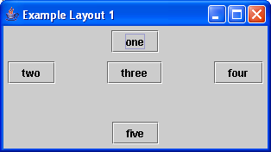
Layout Example 1

FlowLayouts inside BorderLayout.

Leaves each component at its natural size.

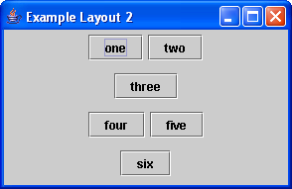
Layout Example 2

FlowLayouts inside BoxLayout.

Allows more than one component per line (and centers the lines).

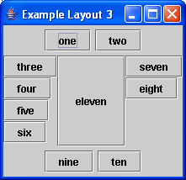
Layout Example 3

FlowLayouts and BoxLayouts inside a BorderLayout.

Allows more than one component per region.
FlowLayouts in the north and south regions (for centering) and BoxLayouts are in the east and west regions.

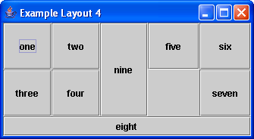
Layout Example 4

GridLayouts inside a BorderLayout.

Allows more than one component per region.

GridLayouts in the east and west regions. Nothing in the north region.

Notice that one of the grid cells in the east region is empty. Normally if only three items were added to a 2x2 grid, button seven would be below button five. To leave that position blank, an empty “placeholder” is used. The placeholder was created with the following command:
Box.createVerticalBox()

(The Box class can create several kinds of invisible components that affect layout: glue, struts, and rigid areas. See the API for details.)

